The Ridge Books

Lee and Bob Linn
213 Sherwood Drive Calhoun, GA 30701 706-263-0152
www.theridgebooks.com

The Ridge Books – Recent Acquisitions – African-American
The following list contains books and other African-American-related material we have acquired during the past few months. The list is divided into sections: Non-Fiction Books; Novels and Poetry; Holloway House Paperbacks and other Black Urban Fiction; Pamphlets, Paper and Ephemera; and Paul Robeson. The special Paul Robeson section is part of an archive of Robeson material that comes from the collection of Edmund Sullivan, a professor at the University of Hartford. He was curator of the Museum of American Political Life at that university. He was also a private collector of much African-American political material. We have indicated other items that come from his extensive collection.
At the end of the listings are small scans or photos of each item. Using our website, www.theridgebooks.com, you may view these plus any additional pictures. To reserve a book, call us at 706-263-0152 or e-mail info@theridgebooks.com to check availability and arrange payment. Please use the number in parentheses at the end of each book description as well as the title. You may also order directly through the website. We accept MasterCard, Visa, Discover and AmEx as well as PayPal, checks and money orders. We will be glad to invoice libraries, institutions and established customers.
Shipping for books in the US by Media Mail is free. Please inquire about expedited or international mail. Every effort will be made to keep the on-line catalog up to date, but all items are subject to prior sale. In the descriptions, a book is hardcover unless the write-up says differently. Also, if no condition for a dustjacket is listed after the size of the book, then the book does not have one. For example, the description VG/VG- indicates the condition of the book followed by the condition of the jacket; VG with no other descriptor indicates that the book does not have a jacket.

THE RIDGE BOOKS AFRICAN-AMERICAN LIST June 2019
BOOKS
Bonner, T. D. (from Beckwourth’s narration). The Life and Adventures of James P. Beckwourth, Mountaineer, Scout, and Pioneer, and Chief of the Crow Nation of Indians. 1st Edition. New York: Harper and Brothers, 1856. Small 8vo. 537pp. +ads. VG. Frontispiece and 12 wood-engraved plates included in the pagination. Original blindstamped cloth with faded spine lettered in gilt. Some edge, corner and surface wear with very minor damage at spine ends. Former owner’s name on front pastedown along with very brief notes in pencil on rear pastedown. Book is square and binding secure with no tears or parting except for very short start at bottom of front hinge. Overall, a solid, very good copy. Jim Beckwourth (c.1800-1866 or 1867) was an American mountain man, fur trader, and explorer. An African-American born into slavery in Virginia, he was freed by his father (and master) and apprenticed to a blacksmith; later he moved to the American West, where as a fur trapper, he lived with the Crow Nation for years. Wagner-Camp notes that, "After many years in the Rockies as a mountain man, Beckwourth journeyed west from New Mexico to California, arriving in 1844. Two years later, he came back to New Mexico with a drove of stolen horses. He returned to California, discovered the pass through the Sierra Nevada that still bears his name, and operated a hotel and trading post in Beckwourth Valley. Sometime after 1858 he returned to his old life in the Rockies. He testified in the Sand Creek investigation in 1865 and died in the following year." Blockson 3235; Cowan p.41; Field 149; Graff 347; Howes B601; Sabin 4265; Streeter 2101; Wagner-Camp 272:1. (16400) 575.00
Chandler, Elizabeth Margaret (Benjamin Lundy, ed.). The Poetical Works of Elizabeth Margaret Chandler: with a Memoir of Her Life and Character, by Benjamin Lundy. [bound with] Essays, Philanthropic and Moral, by Elizabeth Margaret Chandler: Principally Relating to the Abolition of Slavery in America. 1st Edition (2 Vols. in one). Philadelphia: Lemuel Howell, 1836. 180, 120 pp. 12mo. VG-. Full leather, patterned, with faded gilt titles on red panel on spine. Edge, corner and surface wear with light area of damage at top of spine and rubbed corners. One signature is slightly pulled, but book is square and binding secure. Some interior toning and foxing. Tissue guard on frontispiece present. Solid copy. This is two volumes in one, as, it appears, most copies were. The poems comprise the first 180 pages followed by 120 pages of essays. Chandler was a Quaker who devoted her life to the cause of abolition through her poetry and essays. Her poem, "The Slave Ship,' brought her national attention. "The Kneeling Slave," with its engraved image, became so omnipresent that today we would say that it has "gone viral." After moving to Michigan in 1830, Chandler edited Benjamin Lundy's Abolitionist Journal and founded The Logan Female Anti-Slavery Society which became a main link on the Underground Railroad to Canada. She died suddenly at age 27 in 1834, and this book of her works was published by Lundy who also wrote an account of her life. Chandler's was an important and impassioned voice in the abolitionist cause. Only in recent years has her importance and influence begun to be recognized. Blockson 6151. Work p. 308 (Poems only). (16404) 250.00
Fox, Minnie C. The Blue Grass Cook Book. 1st Edition. B&W Photographs by A. L. Coburn. New York: Fox, Duffield & Co., 1904. 350 pp. Small 8vo. VG+. Introduction by Kentucky writer, John R. Fox, who was the brother of Minnie Fox. Original ruled or patterned blue cloth with dark blue titles. Light wear on spine and corners. Light toning on edges though pages are clean. Book is square and binding is secure with no tears or parting. No dust jacket. VG toVG+. On the rear endpaper there are two neatly handwritten recipes, Grandma's Baked Flour Pudding and Custard Souffle'. No other writing except a gift inscription on ffep, dated 1904. Frontispiece and eleven halftone photographs on coated paper by Alvin Langdon Coburn. (Occasionally, descriptions list a frontispiece and twelve photos, but the photos of corn dodger and beaten biscuits are on the same page.) Most of the photographs show African-American cooks who ran the kitchens on large farms; some are named and listed as cooks on specific farms or plantations. All photographs are present. A very attractive copy. (16337) 675.00
Gant, Bess. Bess Gant’s Cook Book: Over 600 Original Recipes. 3rd Revised Edition. Plastic Comb Binding. Culver City: Murray and Gee, Inc., 1947. 79 pp. 8vo. VG. The orange flexible covers have a faded streak, about 1", at the top of both front and back. The corners are slightly worn. Interior, except for light toning, is VG+. This cook book is by a noted African-American celebrity chef, whose clients (as far as I can determine) included Katherine Hepburn, Walt Disney and Sidney Greenstreet. There is a section of recipes from celebrities in the back of the book that includes entries from these three plus many others -- Lena Horne, June Allyson, Hattie McDaniel, Louise Beaver, Gene Tierney and Carmen Miranda. Walt Disney's contribution is Make Mine Music Salad with Mickey Mouse Dressing. While most of the recipes lean toward fancified versions of fairly standard American and Southern dishes, there are some unusual suggestions, such as those for children's parties. For a birthday party - Beef Broth, Chicken Croquette, Mashed Carrots and Creamed Celery. Maybe celebrities' kids in the 1940's had more sophisticated palates than today’s youngsters! The book is fun to read and many of the recipes are worth trying. (16041) 225.00
Keckley, Elizabeth. Behind the Scenes or, Thirty Years a Slave, and Four Years in the White House. 1st Edition. New York: G. W. Carleton and Co., 1868. 371 pp. +ads. 12mo. VG-. This is one of the most important slave narratives as well as a singular account of life at the White House in the last years of the Civil War. Since the book did not have wide readership initially, first edition copies are difficult to find. WorldCat locates at most four copies in libraries. This is a most important work of African-Americana as well as Lincolniana. This copy was deaccessioned from the Morse Institute with that library's label on spine and Institutional bookplates on pastedowns. The book has moderate wear, rubbing at spine ends, edges and corners; the front and rear free endpapers have been excised, occasional stains. The book is square in the G+ to VG- range.This is a solid copy of a truly uncommon and important book. Most information on Elizabeth Keckley comes from this book, though the majority of it has been confirmed through independent research. Keckley was born a slave, married a supposedly free man who turned out to still be a slave. She eventually was able to purchase her freedom and set up a dressmaking shop in Washington DC. Her clients were influential Washington wives including Mary Todd Lincoln. Keckley became Mrs. Lincoln's dressmaker and confidante. After the Civil War and Lincoln's assassination Keckley wrote Behind the Scenes, revealing much personal information on the family at the time of Lincoln's death. The book was quite controversial and did not sell well. In time, Behind the Scenes has become accepted as a major primary source on Mary Todd Lincoln. Keckley tried to continue as a dress maker but lost most of her prominent clients. She taught briefly at Wilberforce University but died in penury. Blockson 9211. Work, p. 312. (16399) 2750.00
Koveman, Jill Beute. I Made This Jar … The Life and Works of the Enslaved African-American Potter, Dave. 1st Edition. Columbia: McKissick Museum, University of South Carolina, 1998. 101 pp. Small 4to. NF. Book appears as new and unread. Beautiful copy. This is a study, with many illustrations, of the early Edgefield, South Carolina potter, known as Dave the Slave. Examples of his work sometimes appear on Antiques Roadshow. (15903) 100.00
Locke, Alain (ed.). The New Negro: An Interpretation. 1st Edition. Color Illustrations by Winold Reiss. New York: Albert & Charles Boni, 1925. 446 pp. 8vo. G. Book has rubbing to the edges and corners of the boards. Some surface wear. Spine has some wear at extremities and is lightly sunned. There has also been some minor damage on the spine causing a light curl resulting in some waviness on interior pages. This has not caused any problem with the binding. This copy is square and the binding is secure with no tears or parting. This is a well-used but not abused copy of an important book. This work with its well-known illustrations was, in many ways, the announcement of the Harlem Renaissance. It includes contributions by Langston Hughes, Jean Toomer, Countee Cullen, Jessie Fauset, James Weldon Johnson, Charles S. Johnson, Kelly Miller, Walter White, W. E. B. DuBois, Alain Locke and many others. Besides Reiss's portraits, there are also works by Aaron Douglas and Miguel Covarrubias as well as material from the Schomberg Collection and African sculpture. Blockson 3618. Work p. 438. (16140) 400.00
A Former Resident of the South (Lyman, Darius). Leaven for Doughfaces; or Threescore and Ten Parables Touching Slavery. 1st Edition. Cincinnati: Bangs and Co., 1856. 332 pp. Small 8vo. VG-. Blindstamped, brown cloth with gilt illustration on front and faded gilt titles on spine. The book has edge, corner and surface wear with corners rubbed to boards and evidence (fading) of an old dampstain on the bottom corners, front and rear. There is no evidence of this dampstain in the interior. Overall the book is square and securely bound, a solid, presentable copy, about VG. This work was an attack on slavery, especially those in the North who allowed Southern ideas on slavery to stand. "Doughface" was a term coined to describe these politicians, whose politics were pliable like dough. This work is attributed to "A Former Resident of the South." It was written by Darius Lyman who was instrumental in publishing it. Important pre-Civil War work, now somewhat overlooked. Work p. 301. (16403) 150.00
Mayer, Brantz. Captain Canot; or, Twenty Years of an African Slaver, Being an Account of his Career and Adventures on the Coast, in the Interior. 1st Edition. New York: D. Appleton and Co., 1854. 448 pp. +ads. 8vo. VG. Deep brown cloth, with gilt titles on spine. This is the first edition, first issue with page 191 misprinted as '19'. Overall light wear, with light scuffed area on spine; a few closed tears within, some foxing and dampstains; very good. Captain Canot was an adventurer who involved himself in all aspects of the slave trade. This book is a vivid and lurid account of how slavery operated. Canot even manages to blame the European slave trade on Africans because some African groups practiced slavery. Blockson 9289. Work p. 262. (16402) 250.00
Peyton, Thomas Roy, M.D. Quest for Dignity: An Autobiography of a Negro Doctor. 1st Edition. Los Angeles: Walter F. Lewis Publisher, 1950. 156 pp. Large 8vo. VG+. Book has light, general wear and some light aging. No jacket but the front flap is laid in. Square and securely bound; a very attractive copy. This is an African-American doctor’s story of trying to find acceptance and dignity in American society prior to 1950. Blockson 7855. (16038) 75.00
Rutling, Thomas. “Tom,” An Autobiography with Revised Negro Melodies. 1st Edition. Softcover. Torrington, North Devon: Thos. Dyer, Publisher, ca. 1907. 64 pp. 8vo. VG. Original printed wrappers, chip to backstrip, otherwise minor wear; foxing to title page and frontispiece, otherwise minimal wear to contents. Overall VG. This is a narrative written by a former member of the Fisk Jubilee Singers. Rutling was born a slave in Tennessee and experienced the loss of his mother who was sold. He was freed in 1865 and was able to go to Fisk in Nashville, Tennessee. He became one of the original Fisk Jubilee Singers and stayed with the group until he left them in England and refused to return to America. He became a true celebrity in England. This short autobiography was published there around 1907. The first 15 pages are devoted to the story of the author's life under slavery, followed by his musical career and 40 pages of music. Very uncommon slave and music-related volume. Not in Blockson. Not in Work. WorldCat listings for this book are confused. There are no more than seven copies worldwide in libraries, probably fewer. (16346) 1850.00
Scarborough, Dorothy (assisted by Ola Lee Gulledge). On the Trail of Negro Folk Songs. 1st Edition. Cambridge: Harvard University Press, 1925. 289 pp. Large 8vo. VG to VG+. Green cloth with gilt titles. Very light corner bumps and edge wear. Expected overall aging. Book is still square and securely bound with no tears or parting. A quite attractive copy. VG to VG+. Scarborough was a musicologist, assisted by Ola Lee Gulledge, who did much field work to record African-American folk songs. She was one of the prototypes for the character in the movie, Songcatcher. This book contains an account of her work in the 1920's and includes musical transcriptions of many songs. Important work on American and African-American music. Blockson lists a reprint only. Work p. 434. (16114) 175.00
Simmons, Rev. William J., D.D. Men of Mark: Eminent, Progressive and Rising. 1st Edition. Cleveland: Geo. M. Rewell & Co., 1887. 1141pp. Large 8vo. VG. Deep, bluish-green cloth with gilt and black titles and illustrations. This copy has been professionally repaired at the hinges and cleaned. It has a slight cock toward the spine. There are a few, almost unnoticeable, scuffs or light spots, mostly visible when the book is angled to the light. Overall, this is a very attractive copy of a book that is extremely difficult to find in the first edition. WorldCat lists no copies of this edition in libraries, though the Hathi Trust has a scanned copy from Harvard. The book itself is what its title says, a compilation featuring 177 short biographies of virtually every African-American "man of mark" up to and including the year of publication. 106 of these biographies have B&W portraits taken from engravings by Murray & Heiss, Engravers. There is an Introduction with a short biography of Simmons by Rev. Henry M. Turner, D.D. William J. Simmons was a minister and an ex-slave who became President of State University in Kentucky, now known as Simmons College of Kentucky. This is an exceptional compendium of African-American biography. Blockson 3376. Work p. 475 (1891 edition) (16455) 950.00
Smith, C. C. The Life and Work of Jacob Kenoly. 1st Edition. Cincinnati: Methodist Book Concern for author, 1912. 160 pp. 12mo. VG. This copy has very light edge wear, light rubbing at corners and a number of spots and small blemishes on the cover. It is square and securely bound. The interior has light aging but is still fresh. A former owner's name is on the ffep and his postage-stamp-sized bookplate is on the front pastedown. He has also made a list of page numbers on the pastedown; some passages are marked with a small check in the margin. Jacob Kenoly would probably be unknown except for this biography. He was the son of slaves in Mississippi. He actively sought education in Edwards, Mississippi and then made his own way to Liberia as a missionary. After some success in establishing a school, he was killed in a boat accident. Interesting work with several photographs. Blockson 8850. (15998) 75.00
Steward, Austin. Twenty-Two Years a Slave and Forty Years a Free Man; Embracing a Correspondence of Several Years, While President of Wilberforce Colony, London, Canada West. 3rd Edition. Rochester: Ailings & Cory, 1861. 360 pp. 12mo. About VG. Illustrated with woodcut plates. Original blind-stamped brown cloth, lettered on spine in gilt. Nicks and chips to cloth at spine ends, edges and corners, lettering faded a bit; Light foxing; Square and securely bound with no tearing or parting. Laid in is a manuscript leaf with period religious reflections. Steward, a fugitive slave from Virginia, settled in Rochester, New York and participated in the underground railway. Somewhat uneasy under the protective laws of New York, he relocated to the Wilberforce Colony in Canada and worked particularly toward the emancipation of slaves from Ohio. He eventually returned to Rochester where he died of typhoid in 1867. He was one of many unsung African-Americans who worked to free slaves. Blockson 10166 (Blockson lists the 1st edition); Work p. 313 (Work lists this edition.) (16401) 500.00
Wesley, Charles H. Prince Hall: Life and Legacy, with 1923 Chicago Temple mortgage bond. 2nd Edition. Chicago: United Supreme Council, Southern Jurisdiction, Prince Hall Affiliation, 1983. 237 pp. 8vo. VG+. Book has very light general wear and aging. It is about near fine. Square and securely bound. No tears, parting or interior marks. (Interestingly, the publication information on the title page has been pasted over with an address label for Drew Sales Lodge Regalia in Chicago which states that that company distributed this book. The Drew company still deals in Masonic regalia. This is a nice association.) Charles H. Wesley was a prominent African-American scholar, minister and author. He was involved with a number of fraternal organizations. This book, a stated second edition is about the Prince Hall Masonic Lodge in Chicago. Prince Hall is the oldest African-American Masonic order in the US. Both this edition and the first (from 1977) are somewhat difficult to find, especially in collectible condition. This volume comes with a 1923 Mortgage Bond sheet that seems to have been used to finance work on the Temple in Chicago. The Bond sheet is of some value itself. Blockson lists the 1977 first edition. (16309) 450.00
Wesley, Charles H. Richard Allen: Apostle of Freedom. 1st Edition. Washington: The Associated Publishers, 1935. 300 pp. Small 8vo. VG. Brick-colored cloth over boards with black titles. Some light edge and corner wear along with minor damage at top of spine, mainly on rear. This copy lacks the scarce dustwrapper. This is a biography of Allen (1760-1831), a former slave who founded the Bethel African Methodist Episcopal Church in Philadelphia, the first church of that denomination in the US. The AME Church is generally credited as the first specifically black denomination. This book is quite scarce in the 1st edition. It was published by Carter Goodson's Associated Publishers in Washington DC in 1935. By that time Goodson was having difficulties, and books often had short print runs. WorldCat locates two copies of this edition worldwide; one in the British Library and a second with no publisher listed at Howard University. Some ephemera related to Richard Allen and the Bethel AME Church is laid in - five post cards, a Founder's Day card, and a small booklet on Sarah Allen, wife of Richard. Blockson 8960 (a later reprint). (16102) 750.00

FICTION AND POETRY
Beadle, S. A. Lyrics of the Under World. 1st Edition. Jackson: W.A. Scott, Publisher, 1912. 148 pp. + Index. 8vo. VG-. Deep green cloth with black titles. It appears to me that the endpapers have been professionally replaced. The book has edge, corner and surface wear with minor wear at spine ends. Some light aging though interior pages on slick stock are still bright. The spine has a very slight roll. The 16 B&W photographs by Richard H. Beadle, the author's son, are all present and are quite well-done. Book is securely bound, a solid VG- to VG. This book is rather uncommon, WorldCat locates, at most, sixteen copies in institutions. The book is of special interest because of the nature of Beadle's poetry. Samuel Alfred Beadle was born a slave in Georgia in 1857. At the end of the Civil War, his mother took him to Jackson, Mississippi. Eventually, Beadle did undergraduate work at both Atlanta University and Tougaloo College, becoming a lawyer in Jackson. Though hampered by racial prejudice and segregation laws, Beadle developed a successful law practice in Jackson. He wrote prose and poetry as a sideline and published two books, Sketches from Life in Dixie and Adam Shuffler, both composed of poetry and short prose sketches, before he wrote Lyrics of the Under World. This latter book received some acclaim at the time and is distinguished by Beadle's forthright statements on race. In his introduction, Beadle explains that the title comes from the fact that he is "a member of that unhappy race of people which are treated as alien enemies in the land of their nativity." He further develops this idea in a number of poems, especially "Lines to Caste" and "The Jaunt." While a contemporary of Dunbar, Beadle does not often write in dialect. His anger at not being free in the land of the free is stated straightforwardly and not hidden within the metaphors of stories and tales. Beadle eventually left Jackson and moved to Chicago where he practiced law until his death. He is a poet worthy of wider notoriety. The photographs in the book, by his son Richard Henry, are of note as well. Richard H. Beadle was one of Mississippi's only black photographers at the time. There have been exhibits of his work at a number of institutions. Not in Blockson or Work. (16120) 650.00
Chesnutt, Charles M. The Marrow of Tradition. 1st Edition. Boston: Houghton, Mifflin and Company, 1901. 329 pp. Small 8vo. VG-. Cloth has some stains and soiling, including old, circular water marks on front and back covers along with light edge and corner wear; spine slightly sunned. Both exterior and interior show expected aging. The rear hinge has been re-glued at some point. Crayon marks on p. 231. Overall, this copy in VG- condition. This is considered to be Chesnutt's finest novel. It deals with the Wilmington, North Carolina race riot of 1898. Blockson 5838. Work p. 472. (16168) 400.00
Hughes, Langston (libretto) and William Grant Still (music). Troubled Island: An Opera in Three Acts. 1st Edition. Softcover. New York: Leeds Music Corporation, 1949. 38 pp. 8vo. VG. Stapled, pale blue wraps with deep red titles. This copy is toned around the edges and has some light wear at the spine but, otherwise, seems unused. Without the toning this would be a near fine copy. This opera, based on the Haitian revolution, was begun by composer Still and librettist Hughes in 1936. Hughes eventually left the project, and the libretto was completed by Verna Arvey who went on to marry Still. This edition, of the libretto only, lists only Hughes as the author. Some controversy surrounds the opera's limited run, since accusations were made that New York critics offered negative reviews because of racist attitudes. Blockson 8181; Bruccoli, FPAA, 3, 170b; Dickinson 17. (16307) 480.00
McKay, Claude. Spring in New Hampshire. 1st Edition. Softcover. London: Grant Richards Limited, 1920. 40 pp. Small 8vo. VG. Tan wraps with publisher's tipped on pale green title panel. Frontispiece of McKay present. Some edge and corner wear with light damage at spine ends and a small, unobtrusive stain at bottom of front wrap. Overall a VG copy. This was McKay's third book and first volume of poetry. He was a major figure in the Harlem Renaissance, and this book is one of his most elusive. Blockson 6467. (16218) 850.00
HOLLOWAY HOUSE
Ayers, Ronald. The Case of the Deadly Triangle: A Leonard Robinson Mystery. 1st Edition. Softcover. Signed by Author. Los Angeles: Holloway House, 1975. 224 pp. 16mo. VG. Pictorial cover with general light wear and a faint reading crease on spine. Bottom right corner also has a small crease. Pages toned as is often the case with Holloway House. Book feels unread. This copy is signed with inscription on the title page. Holloway House books are rarely signed. This was the first novel by Ayers who had been a police officer in Detroit. He does not appear to have written any others. (15921) 65.00
Goines, Donald. Whoreson: The Story of a Ghetto Pimp. 1st Edition. Softcover. Los Angeles: Holloway House, 1972. 279 pp. 16mo. VG+ to NF. Black paperback with red titles and picture of woman. Some light edge and corner wear. Spine is neither cracked nor creased. Binding is square and secure; this copy seems to be unread. Interior has typical light toning of pages. VG+ to NF. This is an especially attractive copy of Goines' second novel and one of his most important. It is also quite scarce in a true first edition in exceptional condition. After Goines' murder, his earlier works were reissued with new covers that mentioned his death, even as the text block still identified them as firsts. This is the true first; no mention of Goines' death. #BH421. (16060) 285.00
Iceberg Slim. Mama Black Widow. 1st Edition. Softcover. Los Angeles: Holloway House, 1969. 313 pp. 16mo. VG. This copy has a bit of minor damage, light creasing and a small scrape on the front bottom corner. Otherwise, there is some general wear and aging along with very light reading creases. Book is still square and securely bound. Overall, this is a solid VG copy. This is a stated First Printing from 1969. It is #HH-176. This was Iceberg Slim's third novel; it is difficult to find in the true first edition. Blockson 5807. (16115) 75.00
Lomax, Louis E. To Kill a Black Man. 1st Edition. Softcover. Los Angeles: Holloway House, 1968. 256 pp. 12mo. VG+. Pictorial wraps with drawings of MLK and Malcolm X. Some light edge and corner wear but square and securely bound. Two light reading creases on spine but book must have been read gently. One small, light diagonal crease on rear bottom left corner. This book by the well-known sixties black newsman and commentator tells the strangely parallel stories of MLK and Malcolm X. Blockson 4200 (16061) 150.00
Washington, Kipp (as told to Leo Guild). Some Like It Dark: The Intimate Autobiography of a Negro Call Girl. 1st Edition. Softcover. Los Angeles: Holloway House, 1966. 223 pp. 12mo. VG+. This copy would be NF to F if not for a small creased area on the top front right corner; the book may have been dropped. The book otherwise feels unread and is in exceptional condition. Holloway House #HH-122. This book initiated Holloway House into the urban black market. At the time (1966) the company had been publishing a variety of subjects most of which were a kind of high class sleaze. This book which purports to be the work of a black call girl, was published almost by chance and sales skyrocketed. From this start, Holloway House began to publish such writers as Iceberg Slim, Donald Goines, Robert DeCoy, Joseph Nazel and many other black writers. This is an important book in the story of the urban black book market. (16097) 75.00

PAMPHLETS, PAPER AND OTHER EPHEMERA
(Allied Printing Trades Council). Political Poster. To the Voters of Hamilton County! Which Do You Want?. Chattanooga: (Democratic Party), ca. 1954. 1pp. 4to. VG+ to NF. This is a political poster from Hamilton County/Chattanooga Tennessee. It is 12 1/2 x 9 1/2 inches with very light, general wear. About near fine. It was printed by the Allied Printing Trades Council, probably for the Democratic Party. It is dated 2 November [probably 1954]. This political poster asks voters to "Remember the Republicans in 1952." Their choices are symbolized by an African-American family in a brand-new convertible, and an old man in rags hauling a cart. Election Day fell on 2 November in 1948, 1954, 1965, 1971, and 1976. The slogan "For Continued Prosperity, Vote Democratic" was apparently rolled out nationally in 1952, and the car in the photograph appears to be a 1954 Chevrolet Bel Air, so we would guess this was targeted at African-American voters in the 1954 Tennessee state elections. Unusual. (16353) 950.00
(Baraka, Amiri). Afrikan Free School, Education Text. 1st Edition. Softcover. New Ark: Jihad Publishing Co., 1974. 36 pp. 8vo. VG+ to NF. Portrait of Imamu Amiri Baraka on 5th page. Original printed wrappers; toning, minimal wear. About near fine. This pamphlet is a fully developed curriculum for the Afrocentric school founded in 1967 by LeRoi Jones/Amiri Baraka in Newark, New Jersey. It is not stated that Baraka actually authored this pamphlet, though, if he did not, he certainly had much influential input. My guess would be that he was the author. The pamphlet includes background on the school's history, philosophy and administration, as well as curriculum grids for pre-school through grade 8. Students were taught in Swahili and English. No copies traced at auction. WorldCat lists eight or nine copies in libraries. Quite scarce. (16343) 600.00
Baraka, Imamu Amiri (LeRoi Jones). Kawaida Studies: The New Nationalism. 1st Edition, Stated. Softcover. Chicago: The Third World Press, 1972. 8vo. 55 pp. VG+. Signed boldly by Baraka on half title page and dated "87." Stapled, yellow wraps with black titles. This copy would be near fine except for light wear at corners and some minor soiling/aging on wraps. This is a collection of six essays by Baraka explaining the philosophy and religion of Kawaida. Essay topics include: technology, women, pan-Africanism, nationalism and values. (16040) 200.00
(Bond, Julian). Vietnam. 1st Edition. Softcover. Probably published in Atlanta in 1967, no publication information is stated. Unpaginated. 4to. VG to VG+. Stapled, comic book in black and white with white title on front. This copy has some light age-toning mainly on edges along with light, general wear from usage. Overall it is VG, perhaps slightly better. The cover drawing on this comic is signed by T. G. Lewis and dated '67. There is no other publication information or indication of the author. However, the story was written by Julian Bond after he was denied his seat in the Georgia Legislature because he had agreed with the SNCC statement opposing the Vietnam War. The story is a history of the War, and opposition to it, especially by blacks. The story is simple and straightforward, made more powerful by Lewis's art. This work has been reprinted on-line by The Sixties Project, but this copy is one of the few originals. It came from the collection of Edmund Sullivan. WorldCat locates only eight copies in libraries though some of these seem to be reprints. (16423) 400.00
Burnham, Louis. Behind the Lynching of Emmet Louis Till. 1st Edition. Softcover. New York: Freedom Associates, 1955. 18pp. 12mo. NF. Stapled, black and white wraps with drawing of Emmet Till. This pamphlet appears to be unused and would be fine except for light aging and one minor bit of light creasing on the back wrap. This is a fiery pamphlet regarding human rights abuses against African-Americans in the South. The pamphlet is not just about Emmet Till, whose murder helped galvanize the Civil Rights movement, but about violence against blacks throughout the South. The author was a civil rights activist who was the editor of Freedom, the newspaper founded by Paul Robeson. Compelling pamphlet from the early days of the Civil Rights Movement. This copy came from the collection of Edmund Sullivan. Blockson 2260. (16405) 200.00
(Church of Christ). Glimpses of Negro Americans. 1st Edition. Softcover. New York: The Department of Race Relations, Federal Council of Churches of Christ in America, ca. 1930. 33 pp. 8vo. VG. Stapled. pale green wraps with black titles and frame. This booklet has been professionally, and almost unnoticeably, re-tipped to the wraps. It has very light age-toning. Overall, the booklet is in solid VG to VG+ condition. This was one of a series of booklets issued by the Church of Christ. While the booklet is not dated, it comes from sometime in the 1930's. Rather uncommon -- WorldCat finds only ten copies in libraries. (16050) 85.00
Clifford, J. R. (ed.). The Pioneer Press, Vol. 3, No. 1, April, 1885. Martinsburg: J. R. Clifford, 1885. 4pp. Folio. VG to VG+. This is a four-page newspaper on good quality newsprint with expected aging and surprisingly light edge and corner wear. There are vertical and horizontal folds from mailing or delivery and some small holes where these folds intersect. Neither the folds nor the holes are obtrusive. A former owner's name is written in ink at the top of the first page. Overall this copy is VG to VG+. This is an important African-American periodical and copies are quite scarce. As best I can tell, WorldCat locates fewer than 20 individual papers in institutions. The story behind this newspaper is quite interesting. In 1864 fifteen-year old John Robert Clifford enlisted in the 13th Regiment of Heavy Artillery, Colored Troops. After his discharge in 1865, he attended Storer College in Harper's Ferry, which was newly created to educate local African-Americans. After Storer, Clifford studied law under J. Nelson Wirner in Martinsburg and became the first African-American attorney admitted to the West Virginia Bar. In 1882 Clifford began publishing The Pioneer Press in Martinsburg. The Press was the first African-American owned newspaper in West Virginia. At first the paper was issued monthly. It later became a weekly and had national distribution. The Pioneer Press was "devoted to the interests and education of the colored race." The paper ended publication in 1917 by order of the United States government because Clifford had had the temerity to criticize US involvement in World War I. At that time "The Pioneer Press was the longest running black newspaper in the country" according to wvcuture.org. Clifford was also a founding member of the Niagara Movement (led by W. E. B. DuBois). In 1906 Clifford arranged for the second annual meeting of this group to be held at Storer College in Harpers Ferry. Clifford died in 1933. (16364) 750.00
(Colored Division, Republican State Headquarters of Tennessee). “Back to Slavery” The New Deal Party and the Negro in Tennessee. Softcover. Nashville: Colored Division, Republican State Headquarters of Tennessee, (1940). 4pp. Large 8vo. VG. Single-fold heavy-stock newsprint pamphlet with general light wear and aging with some minor, flattened creasing on corners. Overall VG. This pamphlet, produced by the Colored Division of the Tennessee Republican Party, goes into detail on segregationist policies of the New Deal Democrats in Tennessee, especially in regard to Civil Service positions, specifically the WPA, NYA and Census. It also mentions Democratic "Jim Crow Offices" and the cynical hiring of blacks to work in predominantly African-American areas of Nashville. The pamphlet is not dated, but since this was used as part of Wendell Willkie's campaign in Tennessee, it must date from 1940. I find no copies of this pamphlet in OCLC/WorldCat. It seems to be very uncommon and of some historic interest since it shows how our two political parties were once quite different in their appeals to African-Americans. This copy came from the collection of Edmund Sullivan. (16412) 100.00
Davis, Angela and Fania Davis. The Black Family: The Ties That Bind. 1st Edition. Softcover. New York: International Publishers, ca. 1987. 23pp. 16mo. NF. Stapled, pictorial wraps with B&W image by Charles White with black and white titles on red background. Booklet shows almost no wear or aging. This booklet by sisters Angela and Fania Davis focusses on the nature and importance of the African-American family. Angela Davis is the well-known activist and Communist whose arrest and trial in the late 1960's brought her international fame. Both she and her sister continue as activists today. This book has photographic images as well as the illustration "Madonna" by Elizabeth Catlett. This copy came from the collection of Edmund Sullivan. (16414) 75.00
Dubois, W. E. Burghardt, F. H. M. Murray and L. M. Hershaw. The Horizon: A Journal of the Color Line, Vol. I. No. 2, February 1907. 1st Edition. Softcover. Washington: The Horizon, 1907. 26pp. 16mo. VG+. Side-stapled, thick card stock with green titles. The word "Sample" is stamped in the upper left corner, probably indicating that this was a copy used to solicit subscriptions and ads. The first two pages of this copy are loose but could easily be tipped in by a conservator. Otherwise, this copy has very little wear -- minor damage at bottom of spine and some ink residue on back edges from the printing process. Having noted the two loose pages, I still doubt that very many copies of this elusive publication exist. The Horizon grew out the Niagara movement and was DuBois's second foray into periodical publication. The magazine printed work from other sources but also original essays, poems and perhaps stories by its own staff. After the NAACP began in 1910, DuBois gave up The Horizon for The Crisis. Copies of this magazine are quite uncommon. As best I can determine, WorldCat lists holdings of individual issues in fewer than ten institutions and none of this particular issue. This copy came from the collection of Edmund Sullivan. (16406) 2750.00
(Garvey, Marcus). Marcus Garvey, Mimeographed Letter, Signed. Kingston, Jamaica: Marcus Garvey, 1933. 1pp. Small 4to. VG+. One page, 11 x 8 1/2 inches, on Marcus Garvey Appreciation Fund letterhead; moderate toning, folds. VG+. This is a mimeographed fundraising appeal over Garvey's signature. It was written after Garvey had been released from prison and deported to Jamaica. He says in part, "I have tried for years to do the best for my Race, but unfortunately I have had many hard hits . . . I have had to make tremendous sacrifices and now I am caught to the hilt. I have had to mortgage my home and personal properties here to carry on the work of service to the race, but due to the lack of loyalty on the part of those who should co-operate for the general good . . . I am about to lose my home and all I possess except in the next twenty days at most I can pay off ten thousand dollars." Two years later, Garvey would leave Jamaica for London. This letter comes with a mimeographed, retained copy of a dramatic telegram sent by the American Negro Labor Congress to Garvey while he was imprisoned in Atlanta. "Your imprisonment is an act of brutal persecution and an attack against all of our suffering people. We demand your unconditional and immediate release and urge you to fight against being deported." This telegram is a single page, 5 x 8 1/2 inches; worn with tape repairs, tears and pencil edits. [Chicago, October 1925]. (16345) 1800.00
Granger, Lester B., et. al. Victory Through Unity: Annual Conference, National Urban League, 1943. 1st Edition. Softcover. Chicago: National Urban League, 1943. 77 pp. Small 4to. VG. Stapled, tan wraps with black titles. Some edge and corner wear with light loss at top left front corner and very minor loss at front bottom left. There are one or two short closed tears on edges and toning on front where books were stacked on this program, along with light overall aging. Binding is still secure and book is square, a solid very good copy with noted problems. This is the report from the National Urban League Conference held September 28 - October 2, 1943. The report has an essay on the general activities of the League followed by over twenty essays, by various authors, on specific topics related to African-American issues in US society in general. This report is rather uncommon. I have been unable to find any copies in WorldCat. (16052) 250.00
(Hampton Institute). Everyday Life at Hampton Institute, with photograph from Hampton laid in. 1st Edition. Softcover. Hampton: Hampton Institute, 1907. 32 pp. plus insert. Large 8vo. VG. Cord-bound, brown wraps with darker brown titles. This copy has light, general wear with anticipated aging. VG to VG+. First edition. There are illustrations of campus buildings, school activities, and students. The booklet lists statistics from 1907 so it dates from that year or the next. Relatively uncommon. WorldCat locates around thirty copies in libraries. This copy comes with an 8X10 photograph. The image shows Native American students in a shoemaking class. On verso it is marked as an "IMMIGRANTS reject" and stamped "Reproduced from the collections of the Library of Congress". A pen notation indicates that the photo is from 1895. This may have been a photograph that was considered for use in an American Heritage magazine article but was not used. The photograph appears to have been made from a negative, though I am not an expert. (16224) 450.00
Hargis, Dr. Billy James. Unmasking Martin Luther King, Jr. the Deceiver. Pamphlet. Tulsa: Christian Crusade, ca. 1962. 8pp. 8vo. VG+. This 3X8, tri-fold pamphlet opens to a total of eight pages It has almost no wear along with very light aging. There is a faint, almost unnoticeable, library stamp at the bottom of the front cover illustration. It seems to read, "Pamphlet Collection, Library, ACC" (presumably American Christian College.) Overall, this pamphlet is close to near fine. Billy James Hargis was one of the famous right-wing radio evangelists of the 1950's and 60's who espoused strong anti-communist, segregationist views. He published the Christian Crusader, where the article off-printed in this pamphlet was first published, and founded American Christian College in Tulsa. The thrust of this pamphlet is that Dr. Martin Luther King, and most other African-Americans who support integration, are Communists. This pamphlet is relatively scarce. WorldCat locates only four copies. This copy came from the collection of Edmund Sullivan. (16422) 75.00
(Hasler, Alfred and Benton Resnik) Martin Luther King and the Montgomery Story. 1st Edition. Comic Book. Nyack: Fellowship of Reconciliation, 1957. 16 pp. Small 4to. VG-. Stapled comic book with image of Martin Luther King behind buses and cars in Montgomery. This copy has some age-toning and soiling along with an old dampstain that shows up on the final leaf on both sides with some very minor evidence on a few other pages. There is some edge wear, short tears and minor chips from use on a few pages. Overall for a 60+ year-old, newsprint comic book, this copy is still quite attractive. I cannot pretend to be a comic book grader, so, as a book dealer, I would say that this falls in the VG- range, with noted flaws. This comic is a rare original from 1957 or 1958. The points of the original printings are copper rather than stainless steel staples and a lightly blurred union printers’ emblem on the rear wrap. Also, this copy is from the collection of Edmund Sullivan, who sought out first printings. The comic is not dated, but most sources think that December, 1957 was the first press run, though there are those who argue for 1958. The comic is a true artifact of the Civil Rights Movement, produced at the end of the Montgomery Bus Boycott and featuring a serious portrayal of MLK and his philosophy of non-violence. The comic was published by the Fellowship of Reconciliation. There is a price of 10 cents on the front cover, but the comics were distributed at no charge throughout the South. Around 250,000 were printed, though most were destroyed through use, neglect or the actions of white authorities. This comic had a recognized influence on the Civil Rights Movement. As African-Americans all over the South read the story of MLK and Montgomery, they also learned King's ideas on non-violence, which became inspirational. Congressman John Lewis has been quoted as saying that he read this comic as a teenager and that it influenced his involvement with the Civil Rights Movement and that the comic was used in workshops where non-violent practices were taught. There was also an early Spanish version, and today Arab versions are still distributed in the Middle East. The comic has almost no publication information except for a block on the back attributing publication to the Fellowship of Reconciliation and an address in Nyack, NY. Research has revealed that the authors were Alfred Hassler and Benton Resnik and the artist was Golden Age illustrator, Sy Barry. These men worked for cartoonist Al Capp's studios. Capp admired MLK and provided these services pro bono. Sy Barry has stated that his signature was originally on the cover but that it was covered by text. While the comic was widely distributed, the newsprint was fragile and only a few copies of this original remain. WorldCat locates only one, in a German library. The Smithsonian has a copy though it may be the Spanish version. A scanned copy is on-line, and there have been many, many reprints since 2006. The book seems to be quite uncommon. It embodies a moment in time at the start of Martin Luther King's involvement with non-violent protest. This book is a palpable reminder of what was about to happen in the American South in the near future. Not in Blackson. (16420) 500.00
Hughes, Langston. Freedom’s Plow. 1st Edition Thus. Softcover. New York: Musette Publishers, 1943. 14pp. Small 8vo. NF. Stapled, beige wraps with light aging and wear. About near fine. This copy is signed by Hughes to fellow writer and supporter of left wing causes, Howard Fast. Fast joined the Communist Party in 1943 and served time in prison for refusing to testify against others before the HUAC. Hughes' own interest in Communism and the nature of this poem make for a strong association between the two writers. This poem was originally read by Paul Muni over the Blue Network on Monday March 15,1943 from 3:45 to 4:00 PM Eastern War Time. Background music was furnished by organ accompaniment and the Golden Gate Quartette. Beautiful Hughes autograph and exceptional association. (16407) 750..00
Lecompte, J. B. Handwritten letter from African-American man seeking employment on the Republican National Committee. New York: (J. B. Lecompte), 1884. 1 pp. 8vo. VG to VG+. Two pages, written on rectos only. (The pages are on the letterhead of the Starin's City River and Harbor Transportation Company in New York City.) Docketing notes on verso of second leaf. Old folds, a couple of pinholes in upper left corner of each page. Overall VG to VG+. This letter is an appeal from an African-American man to Samuel Fessenden of the Republican National Committee, to whom he had given his application for a clerkship the week before. With the election between James Blaine and Grover Cleveland fast approaching, LeCompte urges quick processing of his application. The person who docketed this letter also wrote "colored man" in blue grease pencil at the top of the first leaf. The following is a transcription of the letter: "About (1) one week ago, I brought in my application for a clerkship with the Rep Nat Comm. Handed it to yourself, and was informed by you. [Sen.], that it would be attended to at the very earliest opportunity. Up to date I've rec'd no message, or otherwise encouraged. Will you please put me on as soon as possible! The Hon'ble J. H. Starin is my reference; I am happy to say to you and all others, that I am an earnest worker, and intend to do all the good I can for the cause of the Rep'n Party. I wish to inform you that tis very essential, ay! Tis positively necessary to pay some attention to the voters, the colored voters of "New Rochelle", N.Y. for I am certain that the Democrats are using all their strength, power and cunning, to win them over to their side, by misinforming them, concerning the "long" "past" "career" of one of our candidates. I will call upon you at my earliest convenience, and give you better infor [sic] as to what I would like to do." (16359) 250.00
Marcy, William L. William L. Marcy, Governor of New York, signed document to Governor of Mississippi, concerning slavery and abolition. Albany: State of New York, 1836. 1 pp. NF. 1pp document on “State of New-York, Executive Department” letterhead signed by 11th New York Governor William L. Marcy as “W.L. Marcy” near bottom right. Carefully tipped into oblong cream-colored paper sheet measuring 7.25” x 10.75”. In near fine condition with isolated spot toning recto and minor ink ghost impression verso along with torn away top left corner of sheet that document is tipped to. The official document is 6.625" x 6.875". New York Governor William L. Marcy issued this document from the state capital of Albany to “his Excellency, The Governor of Mississippi” Charles Lynch (1783-1853) on June 6, 1836. The signed document originally accompanied a copy of “the Report and Resolutions adopted by that body [New York State Legislature] on the subject of Domestic Slavery” and a report on “the proceedings of the Abolitionists” (neither included in this lot.) This was a controversial missive, in that New York was predominantly anti-slavery and Mississippi was a slave-holding Cotton Belt state. Thus, while New York was courteously keeping Mississippi informed of its discourse, it was also delivering what might be considered inflammatory news. The fact that New York Governor Marcy, widely known as a Southern sympathizer or “doughface”, could have softened the news somewhat, but New York’s political sentiments would still have alienated many state’s rights Mississippians. (16342) 400.00
Pennsylvania Freedmen’s Relief Association. The Pennsylvania Freedmen's Bulletin, December 15, 1865. 1st Edition. Softcover. Philadelphia: The Pennsylvania Freedmen's Relief Association, 1865. pp. 65-96. Large 8vo. G+. Newsprint wraps that have been professionally tipped together since the original stitching had failed. There is edge and corner wear with some flaking and toning on wraps. The rear wrap is only partly attached and has some loss. This Association used a rather fragile newsprint that has not held up well. This issue gives reports on the Association's work, primarily in the South and lists many individuals, teachers and missionaries who work in various places in the South. Exceptional information. This was the first year of issue of this periodical and by 1868 it ceased publication and was taken over by the American Freedmen's Association. WorldCat locates 16 institutions that hold volumes or individual issues of this publication. It is not always clear precisely what issues are held. (16046) 150.00
Pennsylvania Society for Promoting the Abolition of Slavery. Act of Incorporation and Constitution of the Pennsylvania Society for Promoting the Abolition of Slavery: and for the relief of free negroes unlawfully held in bondage, and for improving the condition of the African race. Edition Unknown. Softcover. Philadelphia: Merrihew & Thompson (for the Society), 1860. 36 pp. 8vo. VG-. Toned newsprint with remnant of original wrap laid down to thin cardboard and tipped to pamphlet. This pamphlet has been professionally re-stitched through the original holes. No text is missing from the front wrap, though it is mainly a remnant. This is the 1860 printing of this pamphlet which had been published a number of times since the beginning of the Society in 1775. Besides the Act of Incorporation and Constitution of this important Abolitionist group, there is also a list, quite lengthy, of all who had been elected members of the Society. WorldCat indicates fewer than ten copies of this 1860 printing in institutions. (16049) 150.00
Richardson, Beulah (Beah Richards). A Black Woman Speaks…Of White Womanhood Of White Supremacy Of Peace. 1st Edition. Softcover. New York: American Women for Peace, 1951. 12pp. (unpaginated). Small 8vo. VG+. Stapled, beige wraps with image of two women -- one black, one white. This copy has only very light general wear and aging. The booklet, which is 12 pages (unpaginated) is a poem written by Richardson in 1951 and read by her at The Women's Workshop at the American Peace Congress held in Chicago in 1951. Richardson is more well-known under the name Beah Richards which she used for her long acting career and under which name later editions of this poem were printed. Richards was nominated for an Oscar in Guess Who's Coming for Dinner and won an Emmy for a guest appearance on the TV show, Frank's Place. She was also a Civil Rights activist, friend and supporter of Paul Robeson, and an American Communist until the revelations by Nikita Kruschev in 1955. WorldCat is a little vague on how many copies of this edition are in libraries since they seem to list all copies under the name Beah Richards. My guess is that this first edition is held by fewer than 20 libraries. This copy is from the collection of Edmund Sullivan. (16411) 125.00
Scott, C. A. (ed. And pub.) The Atlanta Daily World, Special Supplement Program for the 100% Wrong Club. Atlanta: Atlanta Daily World, 1957. 1 p. Elephant Folio. VG to VG+. This is a large (newspaper-sized) sheet on a flexible light card stock used, I think, as a supplement for the 100% Wrong Club in the February 1,1957 issue of the Atlanta Daily World, at the time Atlanta's African-American newspaper. This supplement has only light edge and corner wear, but there is some monor toning, a few small, light stains and a horizontal crease that affects some text. The crease indicates that this supplement was folded into the newspaper. Overall the sheet is VG to VG+. The 100% Wrong Club was an African-American organization, founded in Atlanta to honor achievements in professional, collegiate and high school sports. The awards were given at an annual banquet. This supplement is for the 22nd Annual Banquet. Among the honorees were Hank Aaron, Frank Robinson, Wilt Chamberlain, Wilma Rudolph, Mae Faggs and many others. The membership of the Club is listed, there is a Programme for the banquet and there are photographs of those receiving awards along with other dignitaries. (16365) 150.00
(Southern Christian Leadership Conference). Program: For Martin Luther King and Boston, April 23, (1965). Softcover. Boston: SCLC, 1965. 8pp. Small 4to. VG. Tri-fold (8 pp.) pamphlet for April 23,1965 rally in Boston for Martin Luther King. The pamphlet measures 5.5 X 9.5 and is accordion-folded. There is very light, general wear along with light toning on edges. There is an old vertical crease, mostly flattened, but still there, where this was probably placed in a pocket. There is some toning along these fold lines as well. Overall the pamphlet is VG. The only date on the pamphlet is April 23; there was a rally in Boston on that date in 1965, a little over a month after "Bloody Selma." The pamphlet features information on the Southern Christian Leadership Conference, names of the officers of the Massachusetts Unit of the SCLC, the order of events, portraits of the speakers (Alan Gartner, Ruth Batson, Ralph Abernathy, and Martin Luther King, Jr.), song lyrics, marching instructions, a "Message from Rev. Virgil A. Wood," and a "Message from Dr. Martin L. King." This march was intended as a peaceful protest against the slum conditions and discriminatory segregation of African Americans in Boston. This pamphlet comes from a tumultuous period in the Civil Rights Movement when the Civil Rights Act was taking shape and events like Selma were beginning to affect the consciences of white people everywhere. Copies of this pamphlet are quite unusual. WorldCat locates one only in the Boston Athenaeum. This copy came from the collection of Edmund Sullivan. (16424) 300.00
(The Station Confectionery). The Station Confectionery, Dayton, Ohio, Trade Card, “Where Colored People Are Welcome”. Dayton: The Station Confectionery, ca. 1910. 1 pp, Oblong 48mo. NF. This small, pink trade card has almost no wear. It is near fine. This card is of interest because The Station Confectionery Company opposite Union Station in Dayton says in the second line on the card, "Where Colored People Are Welcome." Union Station opened in Dayton in 1900, and there are early references to people eating ice cream and confections at the station. This card shows the problems that African-Americans faced in doing ordinary activities. That The Station Confectionery saw fit to put their welcome for Colored People implies that similar businesses did not extend such welcome. It is a kind of anti-Jim Crow sign. (16363) 60.00
Student Nonviolent Coordinating Committee and Southern Christian Leadership Conference. Broadside Support Julian Bond! Join Martin Luther King, Jr. Atlanta: SNCC/SCLC, 1966. 1 pp. VG+ to NF. Broadside (5.5" X 8.5") with very light wear along edges with a horizontal fold in middle and light aging. Overall, about near fine. On January 10, 1966 Julian Bond was denied his seat in the Georgia Legislature because of his involvement with SNCC which opposed the Vietnam War. On January 14 there was a protest march in Atlanta in support of Bond. This broadside/flyer was produced by SNCC and the SCLC to encourage participation. It was distributed mainly on college campuses. Dr. Martin Luther King, Jr. was involved in the march and participated. There are wonderful associations on the broadside: MLK, Julian Bond, SNCC, SCLC, Atlanta University, and Ebenezer Baptist Church. Quite uncommon. (16338) 200.00
Student Nonviolent Coordinating Committee. The Student Voice, Vol. 5, No. 8. 1st Edition. Newsletter. Atlanta: SNCC, 1964. 4 pp. Small 4to. NF. This is an uncirculated SNCC newsletter; a single sheet folded to form four pages, including offset photographic illustrations. Slightly toned, otherwise Fine. Initially a monthly publication, then weekly, The Student Voice was nationally distributed and provided coverage of the Civil Rights movement throughout the South. The reporting chronicled sit-ins, strikes, protests, bloody confrontations, court decisions, etc., often accompanied by graphic illustrations from photographs. Additionally, the newsletter became a reliable recruiting and fundraising vehicle. This issue features the articles: Mayhem in Mississippi, Dogs, Fire Hoses Quell Protests, Reluctant Judge Releases Coed, Dick Gregory Sentenced & Fined, Mississippi Freedom Days Spur Registration and more. (16349) 150.00
Sumner, Hon. Charles. The Barbarism of Slavery: Speech of Hon. Charles Sumner on the Bill for the Admission of Kansas as a Free State. 1st Edition Thus. Softcover. Washington: Thaddeus Hyatt, 1860. 32 pp. 8vo. VG-. Toned, beige newsprint wraps with black titles. Some edge and corner wear with a small chip on back (less than dime-sized) with small amount of advertisement text affected. (Chip is laid in.) Old stain on front that shows up on interior pages but is difficult to differentiate from the general toning of pages. This copy has been professionally tipped together and is in very nice condition despite the problems noted. Sumner's speech on the admission of Kansas was widely printed and reprinted and constitutes a fierce attack on slavery. I have not been able to determine the exact printing history, but this seems to be the first printing by Hyatt, and it dates from the year of the speech. (16047) 150.00
(Unknown Author). Negro Advancement Week Handbill, Charles Town West Virginia, 1931. Charles Town: Mt. Zion M. E. Church, 1931. 1 p. Large 8vo. VG. This is a small handbill/flyer promoting Negro Advancement Week in Charles Town, West Virginia. I have not been able to find any specific information on this specific celebration, but West Virginia did have a number of such events sponsored by African-American churches and organizations in the first half of the 20th century. The listed speakers seem to have been connected with black colleges and churches. While this handbill has very light edge and corner wear, there is a good bit of staining or toning. (16387) 250.00
(Unknown Photgrapher). African-American Barbershop Photograph, Oakland California. Ca. 1920. This cabinet photo measures 11 X 8 1/2 approx. with an image size of 7 3/4 X 5 1/2.The mounting cardboard has some edge and corner wear with the top left corner slightly torn away along with stains (left side), soiling and age-toning. The image itself is close to near fine. The photo shows the interior of an African-American barbershop around 1920, maybe earlier. This came in a lot from Oakland, California and is probably from that area. There are several advertising signs on the walls for Hyki Rub. The photo is sharp and close inspection reveals much detail about the shop. Great bit of African-American ephemera. (16278) 150.00
(Various). Letter from the Secretary of the Navy, ..., in Relation to the Present Condition and Probable Annual Expense of the United States' Agency for Recaptured Africans on the Coast of Africa, Etc. Etc. 1st Edition. Softcover. Washington: Gates & Seaton, 1828. 15pp. 8vo. VG. This is a disbound government document in original wrappers, from the 20th Congress, 1st Session [Doc. No. 193]. The front wrap is somewhat soiled with a small closed tear, overall about very good. This document deals with US Government policy, after the slave trade had been made illegal, toward captured Africans who were seized by the US Navy from illegal slave ships. All in all close to 2000 such "recaptured Africans" came under US jurisdiction. Most of these individuals were taken to camps in Key West and Charleston, South Carolina and later returned to Africa, usually Liberia. The document gives detailed descriptions of the camps where detainees were held and lists of most of the detainees. A recent book by Sharla M. Fett, Recaptured Africans: Surviving Slave Ships, Detention, and Dislocation in the Final Years of the Slave Trade, has traced the history of this little-known policy in great detail. This document is uncommon. WorldCat locates only 8 copies in libraries. (16417) 350.00
(Washington, Booker T.). Typed fundraising letter, signed, Tuskegee letterhead. Tuskegee: Tuskegee Normal and Industrial Institute, 1898. 1pp. VG+ to NF. One-page, typed letter, signed by Booker T. Washington, on Tuskegee letterhead, with envelope, seeking financial aid from Mr. Sheldon T. Viele of Buffalo, NY. The letter has mailing folds and age-toning but is otherwise close to near fine. (16347) 650.00
(Willcox, William G., Treasurer of Investment Committee). Principal’s Report to the Trustees, 1916, with two photographs of events on the Tuskegee campus laid in. 1st Edition. Softcover. Tuskegee: Tuskegee Normal and Industrial Institute, 1916. 19 pp. Large 8vo. G+ to VG-. Originally stapled pamphlet with image of Booker T. Washington and black titles. Staples are missing and spine was long ago taped. Interior pages are held together by the tape. Overall this is VG except for the tape repair. The pamphlet, an annual financial report, has some light edge and corner wear along with a dogear and a short tear at top right corner of front cover. Both interior and exterior age toning. This report is from the year after Washington's death. These annual reports are somewhat scarce. WorldCat locates only five from any year in libraries. This Report comes with two 8X10 photographs from the College. One is of an event at Tuskegee which shows what I take to be the college band playing for female students. The back of the photo is stamped, "Reproduced from the collections of the Library of Congress." A second stamp says, "American Heritage Mag., Reject." In pencil is a notation indicating that the photographer was Frances Benjamin Johnston and some other notes having to do with American Heritage Magazine, which obviously considered the image for a story. I would assume that this photo was reproduced from the original negative, though I do not know that. The second photo shows students clearing land at Tuskegee in 1903. It is also by Johnston and has similar information on the back. (16223) 175.00
Williams, Robert F. The Crusader, March 1968, Vol. 9 No.4. Softcover. Peking, China: Robert F. Williams, 1968. 16pp. Small 8vo. VG. Stapled, off-white newsprint, self-wraps with black titles and B&W drawing/cartoon illustration. Some light wear and aging along with an old diagonal crease on the rear wraps and a light ding to the bottom right corner. This issue is in the VG to VG+ range, still square and securely bound. An attractive copy. This issue of Robert Williams' The Crusader states that it was published in China while he was "IN EXILE". Williams had worked actively for civil rights in Monroe, North Carolina, beginning as President of the local NAACP. Over time he became more and more radicalized until he fled the country when unjustly accused of kidnapping in Monroe. (He actually shielded a lost white couple from a mob.) He had been publishing The Crusader in Monroe and continued it first in Cuba and later in China. The cartoon on the front wrap of this issue shows African-Americans being lynched and beaten by whites wearing KKK robes, Nazi regalia, horns and clerical robes. It is labelled, "Land of the Tree. Home of the Grave." It is a powerful image, credited to "Anne B. Lim, 1963." Williams eventually returned to the US. Huey Newton credited him as an inspiration, and Rosa Parks spoke at his funeral. Copies of this publication are somewhat scarce. OCLC lists around twenty-five institutions holding at least one copy, but searches of the individual listings often produce no results. This copy came from the collection of Edmund Sullivan (16419) 100.00

PAUL ROBESON (all of the entries in this section are from the collection of Professor Edmund Sullivan. See our Introduction for more detail.)
Bogelsack, Brigette. Paul Robeson: korrespondierendes Mitglied der Akademie der Kunste der Deutschen Demokratischen Republik, Grundungsmitglied des Weltfriedensrates, Lenin-Friedenspreis trager. Softcover. Berlin:Akademie der Kunste der Deutschen Demokratischen Republik, Paul Robeson Komitee der DDR, 1975. 19pp. 4to. VG+. Stapled, toned newsprint wraps with a number of B&W photographs. Except for the toning, particularly along the spine and top edge, this copy would be near fine. It has very little wear. This is an East German imprint (in German) that seems to be a compilation of articles on, and in some cases, by Paul Robeson. Some of them seem to be about visits he made to East Germany while others are about his work for Civil Rights in general. My German is very limited. This booklet seems to be uncommon. This is difficult to look up on WorldCat but there seems to be a minimum of four and no more than ten copies in libraries. (16445) 125.00
(Greenstone, Al). Paul Robeson Souvenir Book. 1st Edition. Softcover. New York: Al Greenstone/ Columbia Concerts, ca. 1945. Unpaginated. 4to. VG. Stapled, large (4to), souvenir book with pictorial wraps featuring an exceptional B&W image of Robeson against a white background and white titles on a red banner at bottom. This copy has had the cover professionally reattached with archival materials -- the repair is not noticeable. Otherwise, this copy has only light wear and aging. I have graded it VG because of the repair but it looks VG+ at a minimum. This Souvenir book, which tells Robeson's life story and is filled with photographs, was produced for the Columbia Concerts, Inc. by Al Greenstone, who was well-known for compiling such volumes. There are also brief profiles of other people who were important in Robeson's career including Lawrence Brown, Eugene O'Neill, Carl Van Vechten, Alexander Woolcott and several others. This Souvenir book is quite scarce. WorldCat locates only two copies in libraries. (16446) 125.00
(Robeson, Paul). Paul Robeson, The Great Negro Singer, Program, Eastman Theatre, 1931. Softcover. Single-fold, salmon-colored programs with black titles, red imprint of the Eastman Theatre and engaging B&W photograph of Robeson. This program accompanied the Eastman Theatre Concerts of January 23, 1931 which featured Robeson with Lawrence Brown on piano. The interior pages include an interesting biography of the great singer while the back panel has blurbs from reviews of Robeson's performance at other venues. I suspect there may have been an insert, not present, that included the specific music for this concert. The program is in very attractive condition with only very light wear and one small indentation top center with a quarter-inch closed tear. 4pp. Small 4to. VG+. (16408) 150.00
(Robeson Paul), The Emperor Jones, Provincetown Playbill, Program, 1924-25. Softcover. Provincetown: Experimental Theatre, 1924. 6pp. Large 8vo. VG+. Bifold program, making six pages on beige stock. Very light wear and aging with a few toned spots. The program also has a very small tear and a short slit at bottom of initial fold. Overall the program is in VG+ condition. This rare playbill came out the same season that the Experimental Theatre did All God's Chillun Got Wings, which also starred the young Paul Robeson. Here, Robeson played one of his more famous roles, Brutus Jones Emperor, the title character in Nobel Laureate Eugene O'Neill's drama. This play premiered in Provincetown in 1920. This program is from the 1924-5 season and features the cast of the play, and an essay, "The Negro as Artist" by Walter White, Langston Hughes' poem "The Negro Speaks of Rivers and many ads. The program is quite scarce. OCLC locates only two copies. (16409) 400.00
(Robeson, Paul, et. al.) Souvenir Programme Paul Robeson Peace Arch Concert, August 1, 1954. 1st Printing. Softcover. Vancouver, BC: Union Printers, Ltd., 1954. Unpaginated. Small 4to. VG-. Stapled, beige program with green titles and green-tinted photograph of Robeson. Some, mainly light, edge and corner wear but with some toning and soiling including several small spots on the wraps. Please see scan. This is a program for the third Peace Arch Concert given by Paul Robeson on the US-Canadian border. Because of Robeson's sympathies toward Communism the US Government had taken his passport and he was not allowed to leave the country. The first Peace Arch Concert was held on the border near Vancouver in 1952. This third Concert was the last. WorldCat locates only one copy of this program for the 1954 concert. (16432) 125.00
Westchester Committee for a Fair Inquiry into the Peekskill Violence. Eyewitness: Peekskill U.S.A. Aug. 27; Sept. 4, 1949. White Plains: Westchester Committee for a Fair Inquiry into the Peekskill Violence, 1949. Unpaginated. Small 4to. VG. Stapled, gray wraps with white titles. Some light edge and corner wear, mainly small scuffs from use along with light toning/soiling. Still square and securely bound, an attractive copy. Back cover features a statement by Paul Robeson. After a Robeson concert in Westchester County, New York, attendees were violently attacked by white mobs with what appeared to be the blessing of the police who simply watched the events. Robeson's Communist sympathies along with racism appeared to be the motivations for the attack. This booklet, aimed at seeking justice, includes a full account of the incident along with a eight-page section of photographs. (16413) 125.00
The following is a list of less expensive Paul Robeson-related material. Pieces may be purchased individually or as a lot. These are programs, pamphlets, and booklets of various sizes. If you have questions about any item(s), please inquire. All of these items are from the collection of Professor Edmund Sullivan.
Othello, The Moor of Venice, Program. New York: Theatre Guild, 1945. VG. (16434) 25.00
Robeson, Paul, Forge Negro-Labor Unity for Peace and Jobs. New York: Political Affairs Reprints, 1976. NF. (16436) 25.00
Robeson, Paul. The Negro People and the Soviet Union. New York: New Century Publishers, 1950. NF. (16437) 25.00
The Playgoer, Othello Program. San Francisco: Geary Theatre, ca. 1945. VG. (16438) 75.00
Birthday Celebration Program. Denver: Birthday Celebration Committee, 1978. VG. (16439) 50.00
Patterson, William. In Honor of Paul Robeson. New York: CPUSA, 1969. VG-. (16440) 25.00
Brown, Lloyd L. Lift Every Voice for Paul Robeson. New York: Freedom Associates, 1950. NF. (16441) 35.00
All God’s Chillun Got Wings, Program. London: Embassy Theatre, 1933. VG-. (16442) 60.00
Othello, Playbill Program. New York: Sam S. Shubert Theatre, ca. 1943. VG. (16443) 50.00
The Institute of Arts and Sciences Columbia University, Program. New York: Columbia University, ca. 1940. VG. (16444)) 35.00
Program, Kiel Auditorium, St. Louis. St. Louis: Entertainment Enterprises, ca. 1943. VG-. (16447) 20.00
Program, Paul Robeson and Lawrence Brown in a Soul Stirring Concert of Negro Music. (Symphony Hall?): Paul B. Pond, 1926. VG. (16448) 40.00
Robeson, Paul. For Freedom and Peace. New York: Council on African Affairs, 1949. VG-. (16449) 30.00
Steele, James. To Live Like Paul Robeson. New York: New Outlook Publishers, 1949. VG. (16456) 20.00
Oppenheimer Concert Series, Program. San Francisco; Oppenheimer Concert Series, 1931. VG-. (16457) 25.00

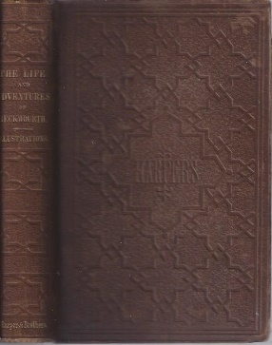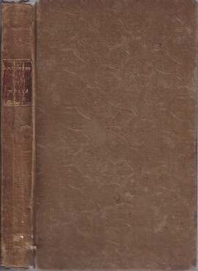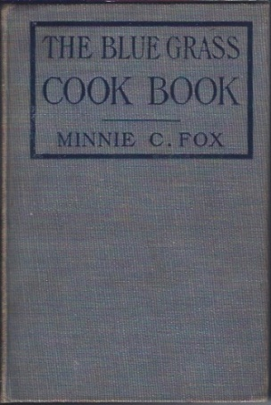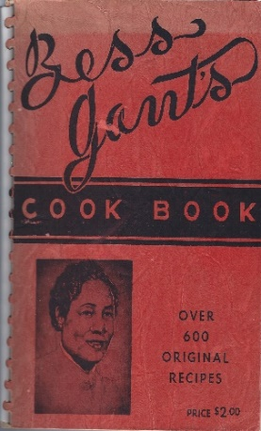
16400 16404 16337 16041
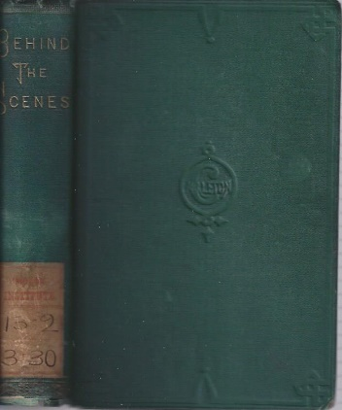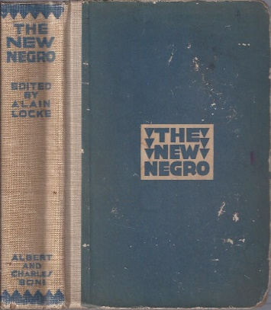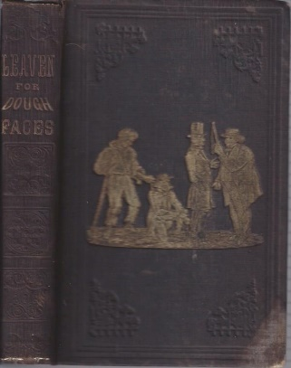
16399 15903 16140 16403
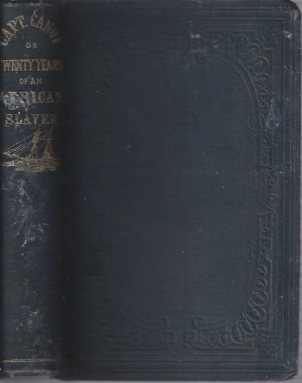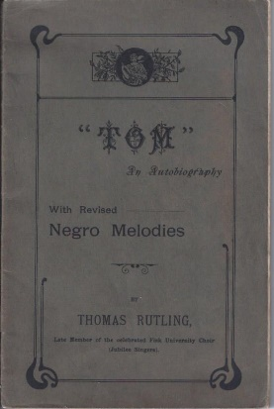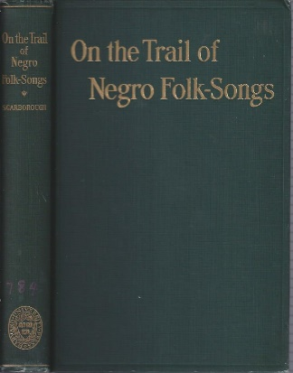
16402 16038 16346 16114
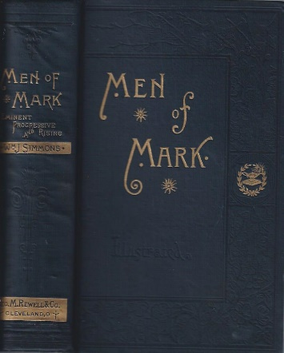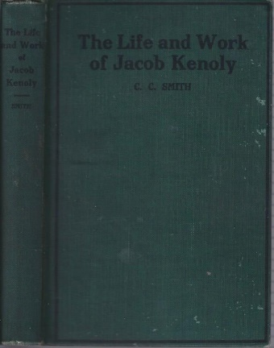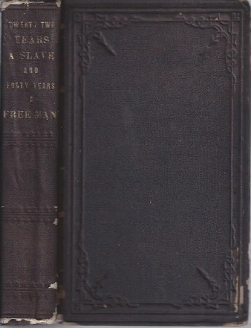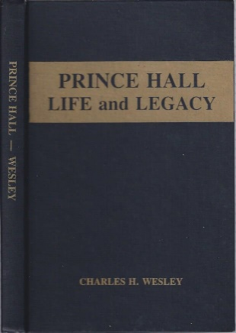
16455 15998 16401 16309
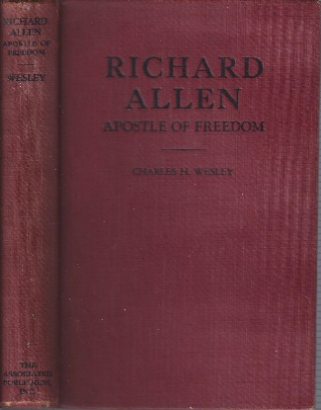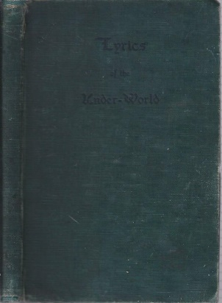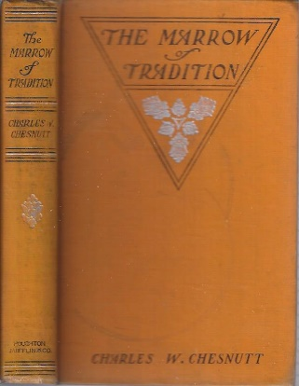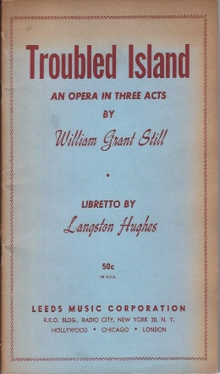
16102 16120 16168 16307
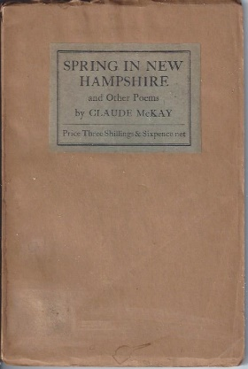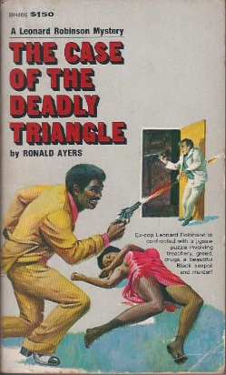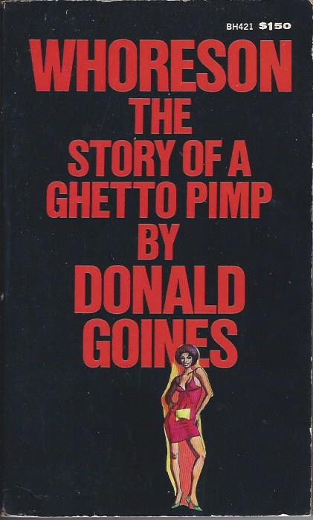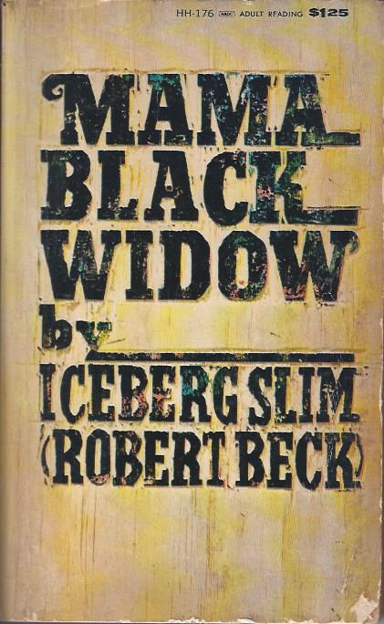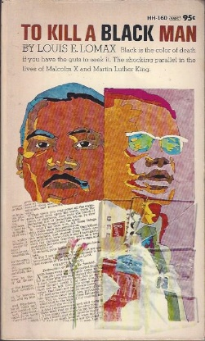
16218 15921 16060 16115 16061
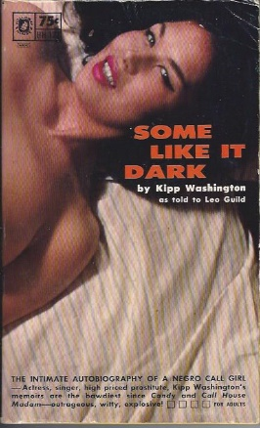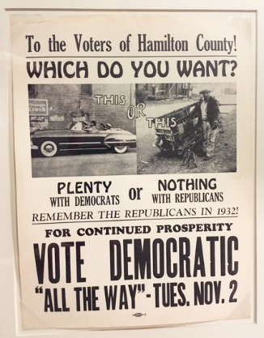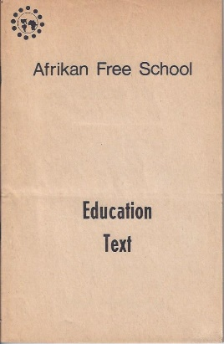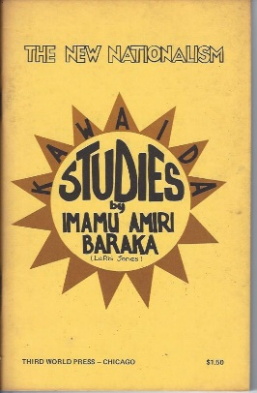
16097 16353 16343 16040
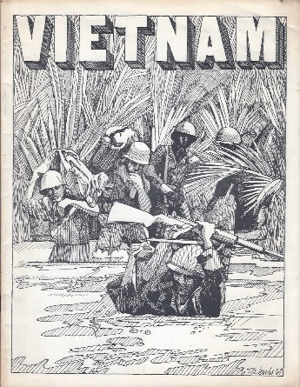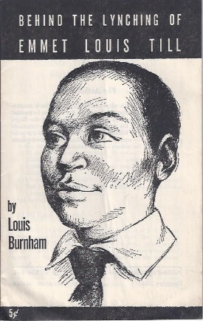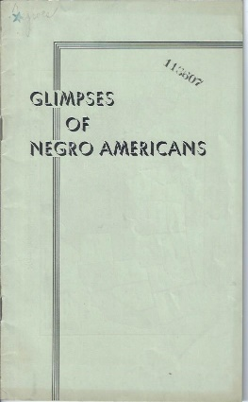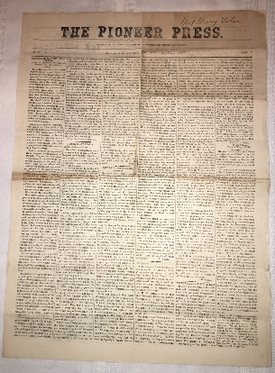
16423 16405 16050 16364
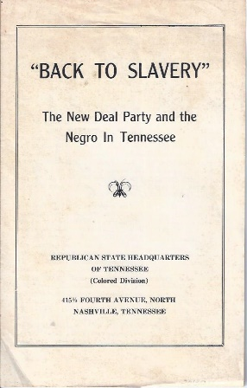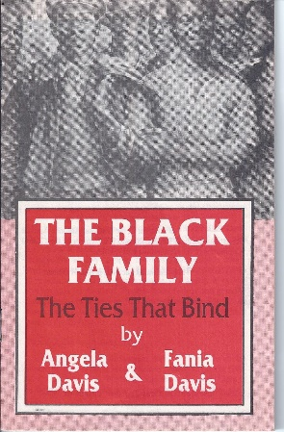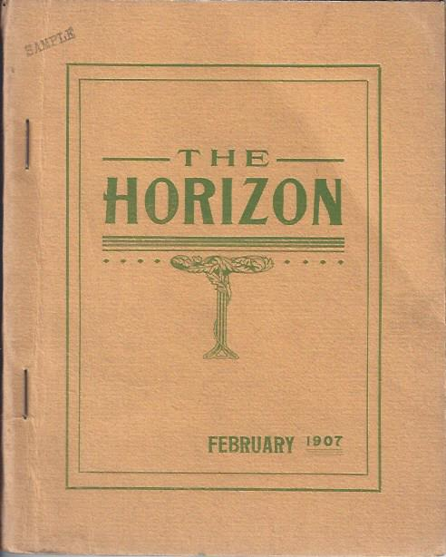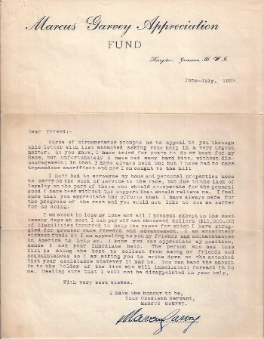
16412 16414 16406 16345
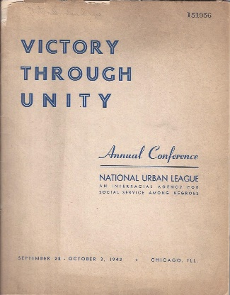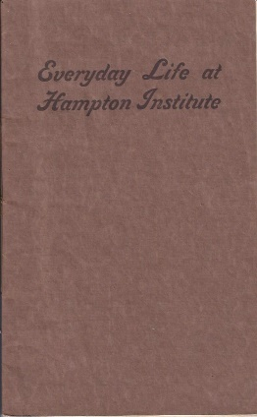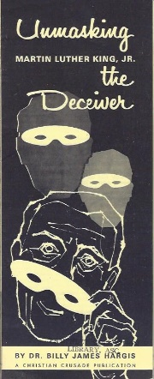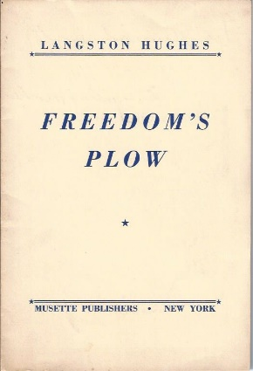
16052 16224 16422 16407
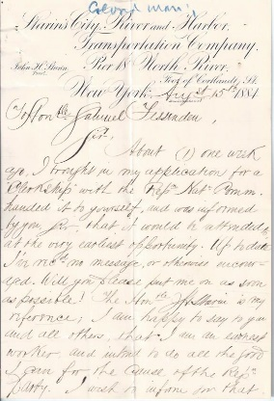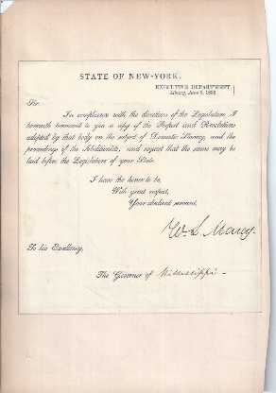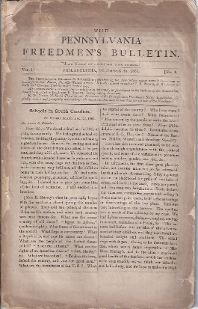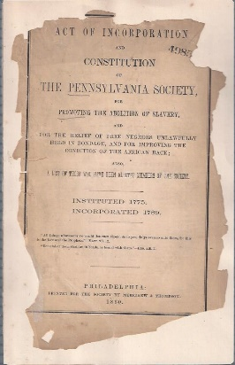
16359 16342 16046 16049
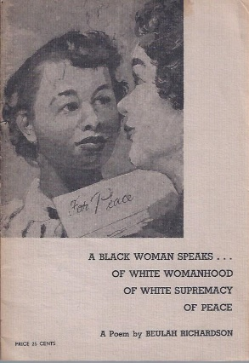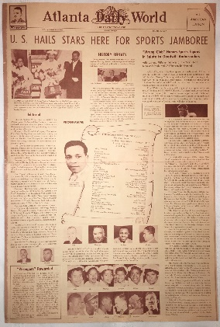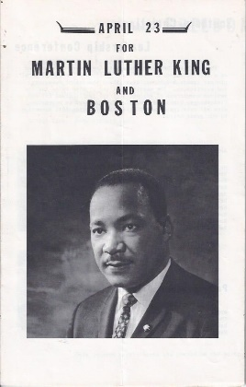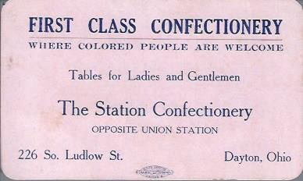
16411 16365 16424 16363

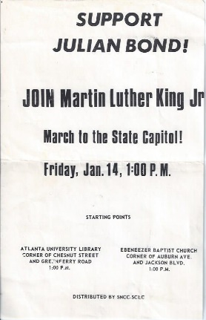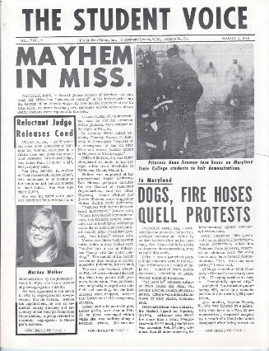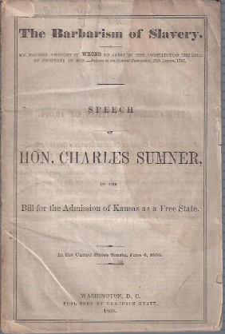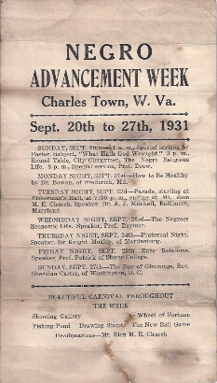
16338 16349 16047 16387
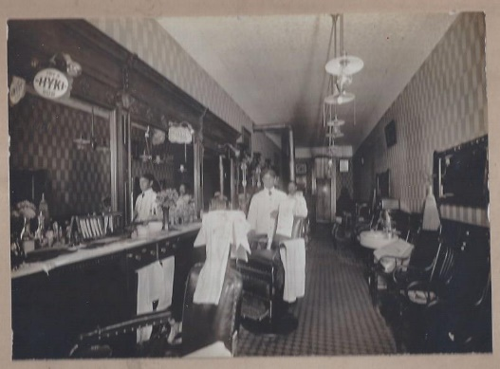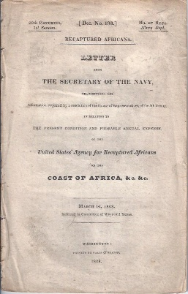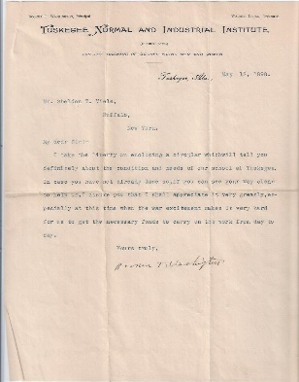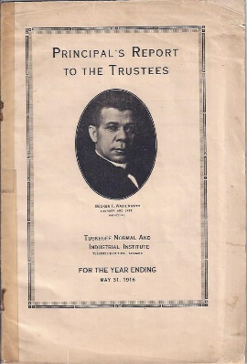
16278 16417 16347 16223
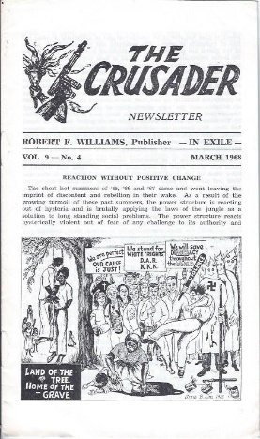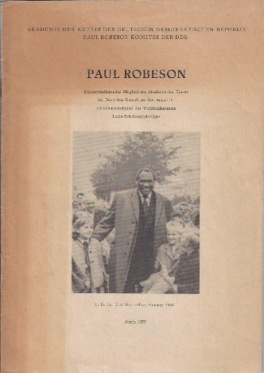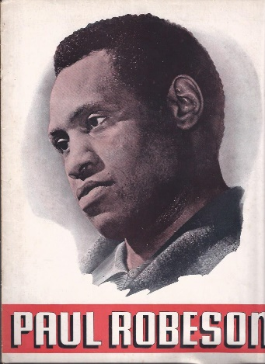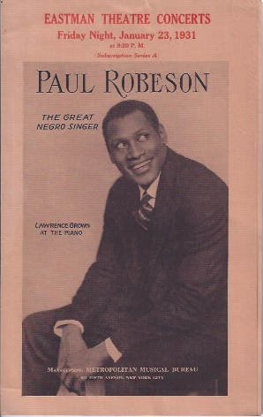
16419 16445 16446 16408
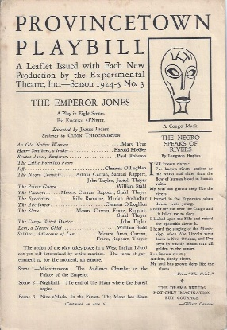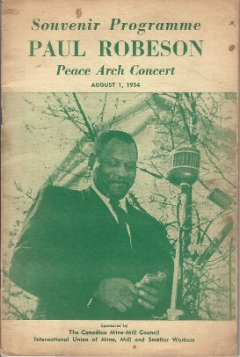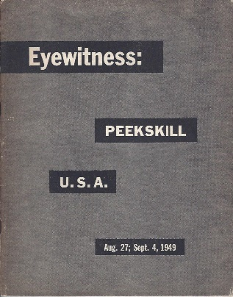
16409 16432 16413

